
REPORT

This box should appear on the window of the standard industrial/practical training cover made available by the faculty. Ideally it should be Center, Cap, Times New Roman, size 14 (for the first line, 12 for the remaining lines) and Bold. But if the company’s name is long, the size may be reduced. Only the company’s name should appear on this window. No address of the company yet.

INDUSTRIAL TRAINING REPORT
(Size 14)
at
(INDUSTRY ATTACHED)
(STUDENT’S NAME )
(STUDENT ID)

(Center, Cap, Times New Roman, Size 18, Bold, at the top of the page)

UNIVERSITI TEKNOLOGI MARA

INDUSTRIAL TRAINING REPORT
(Centered, Cap, Times New Roman, Size 18, Bold)

At

(Address of Industry Attached)
(Duration)
(Centered, Times New Roman, Size 14, Bold)

(STUDENT’S NAME)
(STUDENT ID)
(Center, Cap, Times New Roman, Size 14, Bold)

Report submitted in partial fulfillment of the requirement
for the degree of
Diploma In Computer Science

Kolej Pengajian Pengkomputeran, Informatik dan Matematik

(Center, Times New Roman, Size 14, Bold)

(Center, Cap, Times New Roman, Size 14, Bold)
FEBRUARY 2024

Middle of the page

Approved by:
(Center, Cap, Times New Roman, Size 14, Bold)

Name | : | (Academic Supervisor’s Name)  (Cap, Times New Roman, Size 14, Bold)
Department | : | Information Technology  (Times New Roman, Size 12)
Signature | :
Date | :

ACKNOWLEDGEMENTS
(Center, Cap, Times New Roman, Size 14, Bold)
Alhamdulillah, praise be to Allah for giving me enough time to complete this project.

First and foremost, I would like to express my gratitude to my supervisor, Encik Muhamad b Abdullah for his guidance, advice, co-operation, encouragement and useful ideas in completing this report.
(Times New Roman, Normal, size 12, 1.5 spacing, no indentation for a new paragraph)

.

.
Date: Name:
TABLE OF CONTENTS  (Center, Cap, Times New Roman, Heading 1 Size 14, Bold) | Page
ACKNOWLEDGEMENTS(Cap, Times New Roman, Size 12, Bold) | ii
TABLE OF CONTENTS | iii
LIST OF TABLES | vii
LIST OF FIGURES | viii
CHAPTER 1: INTRODUCTION(Cap, Times New Roman, Size 14, Bold)  - Background of Industrial Training (Times New Roman, Size 12)  - Background of Organization  - Background of Department Attached | 1
CHAPTER 2: ASSIGNMENTS (Cap, Times New Roman, Size 14, Bold)
  - Task 1(Title)
    - Introduction (Including design goals)
    - Objectives
    - Project Planning
    - Project Analysis and Design
    - Implementation
    - Project Testing
    - Result and Discussion
  - Task 2(Title)
    - Introduction (Including design goals)
    - Objectives
    - Project Planning
    - Project Analysis and Design
    - Implementation
    - Project Testing
    - Result and Discussion

CHAPTER 3 : CONCLUSION AND RECOMMENDATIONS(Cap, Times New Roman, Size 14, Bold)
- Benefits of the Assignments
- Summary of Industrial Training

BIBLIOGRAPHY (Cap, Times New Roman, Size 12, Bold)
APPENDICES

LIST OF TABLES

(Center, Cap, Times New Roman, Size 14, Bold)
Page
Table 1: Global Error for Problem 1
Table 2:
Table 3 :

Example of labeling the table in the text.

Table 1: Global Error for Problem 1
Step size  (h) | Explicit Two-step  Hybrid Method | Singly Diagonally  Hybrid Method | Implicit Singly Diagonally  Hybrid Method
0.01 | 3.29949x10⁻⁷ | 1.13312x10⁻⁸ | 3.65703x10⁻¹⁰
0.0625 | 8.06137 x10⁻⁵ | 2.73627x10⁻⁶ | 9.35346x10⁻⁸
0.1 | 3.31331 x10⁻⁴ | 1.2251x10⁻⁵ | 1.52888x10⁻⁶
0.125 | 6.46571 x10⁻⁴ | 2.033555x10⁻⁵ | 2.54506x10⁻⁶
0.25 | 5.156673 x10⁻³ | 1.75805 x10⁻⁴ | 1.48155 x10⁻⁵
0.5 | 4.0561619 x10⁻² | 1.283957x10⁻³ | 7.57578x10⁻⁵

LIST OF FIGURES

(Center, Cap, Times New Roman, Size 14, Bold)

Page
Figure 1:
Figure 2: Monthly Averaged Hourly Relative Humidity 1998-2002
Figure 3:
Figure 4:

Example of citing figures in the text.

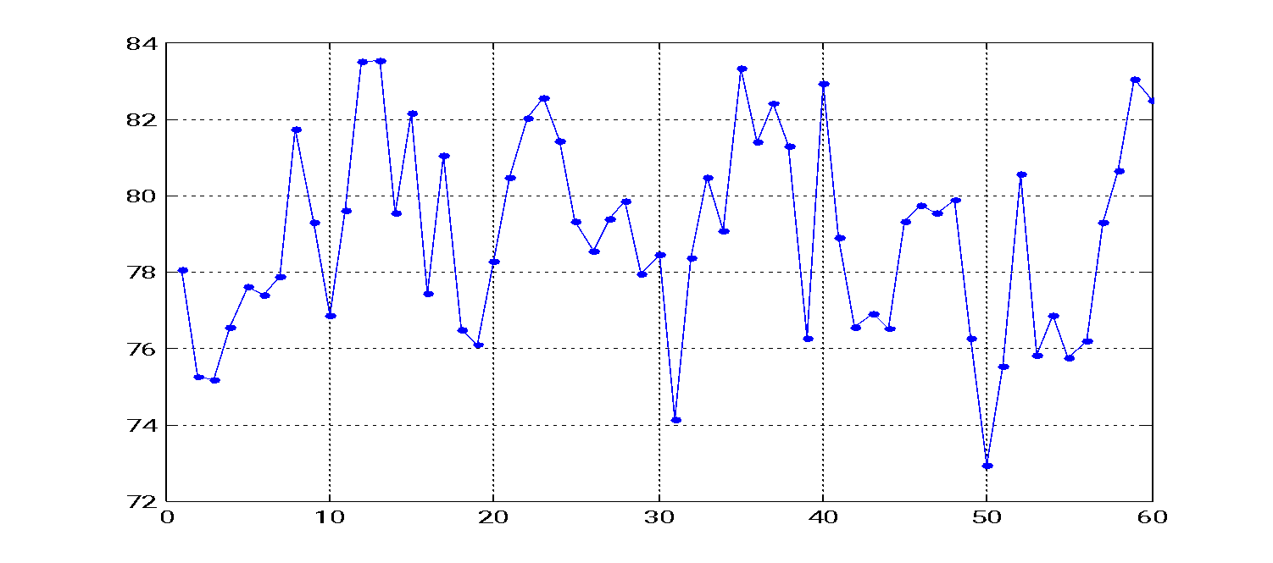
Figure 2: Monthly Averaged Hourly Relative Humidity 1998-2002

CHAPTER 1
(Center, Cap, Times New Roman, Size 14, Bold)

INTRODUCTION

1.1 Background of Industrial Training (Times New Roman, Bold, size 12, Left)

The number of pages of the report should not exceed 30 pages.

  - Background of Organization
In this section you will describe the organization that you are attached to.
  - Background of Department Attached
In this section you will describe the department that you are attached to.

CHAPTER 2
(Center, Cap, Times New Roman, Size 14, Bold)
ASSIGNMENTS

  - Task 1 (Title of the task 1)
Write down the title of task 1.
    - Introduction
Describe task 2.1 that you carried out during your industrial attachment including design goals.
    - Objective
List the objectives (at least 2 or 3) of task 2.1 that you carried out during your industrial attachment.
    - Planning
Describe the project planning of task 2.1 that you carried out during your industrial attachment.
    - Project Analysis and Design
Describe the project analysis and design of task 2.1 that you carried out during your industrial attachment.
    - Implementation
Describe the implementation of task 2.1 that you carried out during your industrial attachment.
    - Project Testing
Describe Testing of task 2.1 that you carried out during your industrial attachment.
    - Results and Discussion
Describe the results and discussions of task 2.1.

  - Task 2 (Title of task 2)
Write down the title of task 2 which differs from task 1. You may have more than two tasks.
    - Introduction
Describe task 2.2 that you carried out during your industrial attachment.
    - Objective
List the objectives (at least 2 or 3) of task 2.2 that you carried out during your industrial attachment.
    - Planning
Describe the project planning of task 2.2 that you carried out during your industrial attachment.
    - Project Analysis and Design
Describe the project analysis and design of task 2.2 that you carried out during your industrial attachment.
    - Implementation
Describe the implementation of task 2.2 that you carried out during your industrial attachment.
    - Project Testing
Describe Testing of task 2.2 that you carried out during your industrial attachment.
    - Results and Discussion
Describe the results of task 2.2 and discuss.

CHAPTER 3
(Center, Cap, Times New Roman, Size 14, Bold)
CONCLUSION AND RECOMMENDATIONS

  - Benefit of the assignments
Describe the benefits from the tasks that have been carried out.

  - Summary of Industrial Training
Write down the benefits that you have gained from industrial training.

BIBLIOGRAPHY
(Cap, Times New Roman, Size 12, Bold)

Example of citing the bibliography

[3] E. M. Barrow and R. J. Lee, 2000. Climate Change and Environmental Assessment, The Canadian Institute for Climate Studies. Retrieved May 17, 2005.

[4] E. Wesker, 1996 Climate Change; a summary of some present knowledge and theories.
Retrieved June11, 2005 from http://www.users/e_wesker/climate.html.
APPENDICES (Cap, Times New Roman, Size 12, Bold)
A:
B:
C:

